User Manual
Programmable High-Voltage Power Supply for CAP Plasma Generator
Setup the Power Supply
- The power supply is in a PVC junction box. There are two terminal blocks at the back of the power supply and the blocks are red and black in colour. This is the input power supply of 27V to 30V. Connect a DC source to the terminal blocks where the red terminal block is the positive and black terminal block is the negative.
- The opposite side of the power supply has two alligator clips. These clips are the two ends of the flyback transformer secondary windings. Connect the alligator clips to the cold plasma generation apparatus.
- The side of the power supply has a cable with a USB connection at the end. Connect this to the desktop computer or laptop.
Setup up the Software
- Launch R2024a or later version of MATLAB application.
- Click on the Apps section on the top ribbon of the MATLAB application. Click on the Design App button on the top right of the ribbon in the Apps Section. Figure 1 shows the Design App button in red.
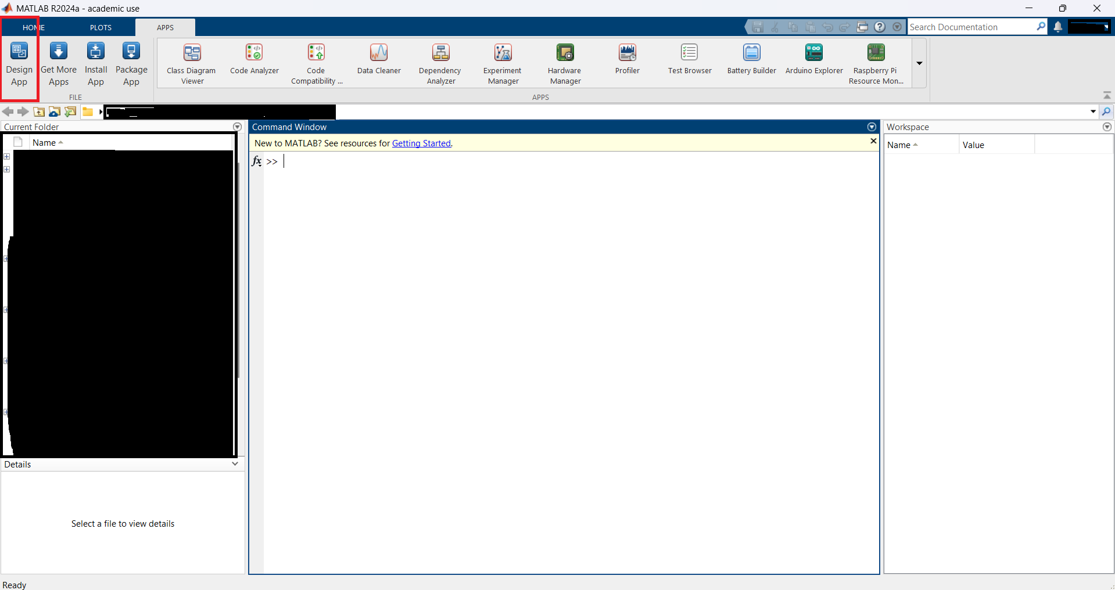
Figure 1: MATLAB Application
- MATLAB App Designer should be opened. Click on the Open button on the left side of the application and locate the file called “Desktop_Application_for_HV_Supply.mlapp” located on the device.
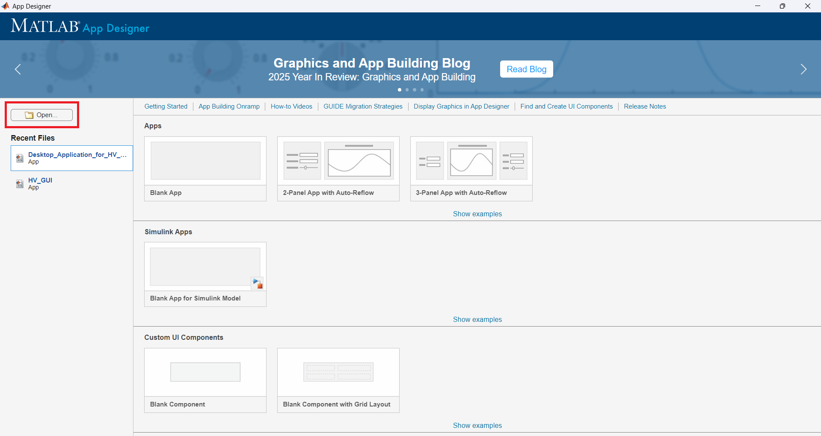
Figure 2: MATLAB App Designer
- The application is opened. Click Run on the top left of the ribbon to start the user interface application.
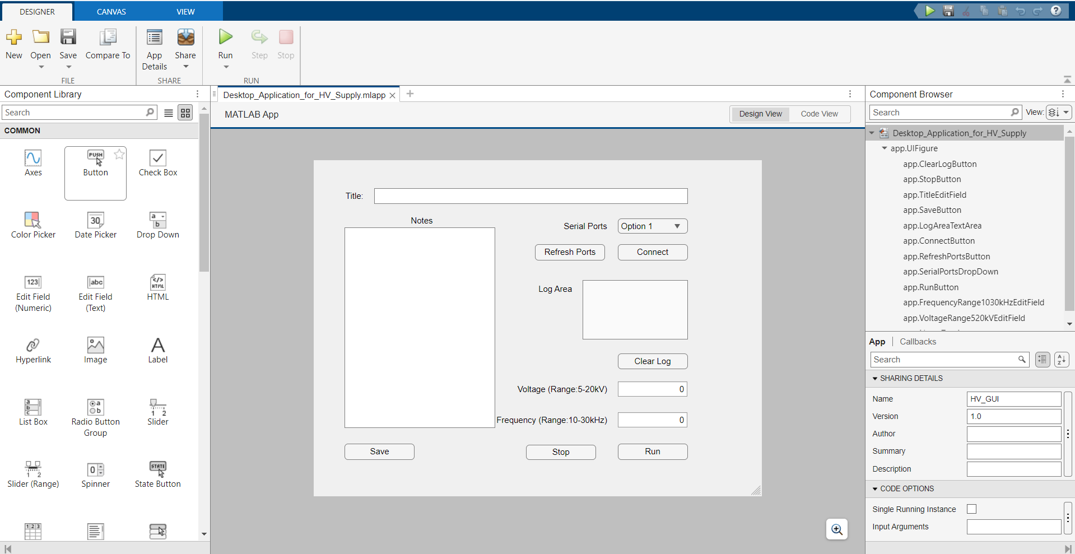
Figure 3: Desktop Application opened in App Designer
- The application has started and Serial Ports drop down menu will show all USB devices connected to the desktop computer or laptop.
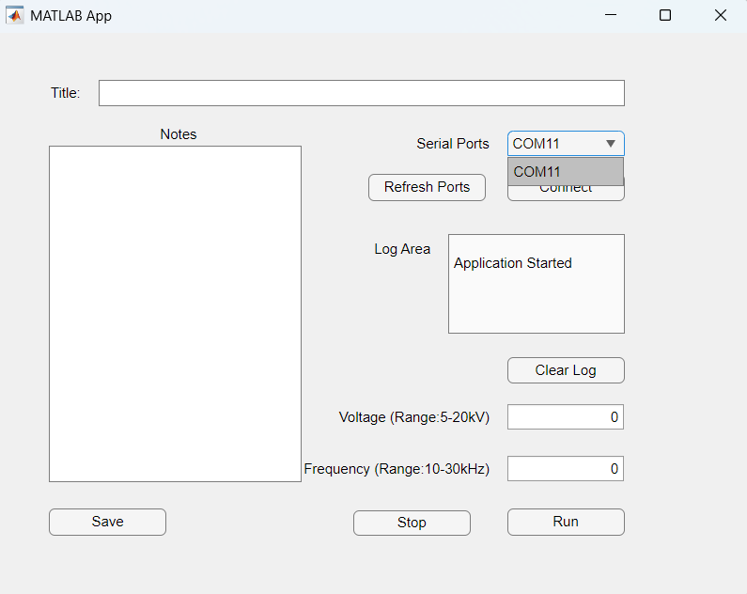
Figure 4: Available Serial Ports
- If there are multiple Serial Port shown in the drop down. The correct port can be identified by access the device manager. Go to the search bar on task bar at the button of the screen and search device manager and open the application. Scroll down to Ports and click the drop-down arrow. The names of the USB devices are shown.
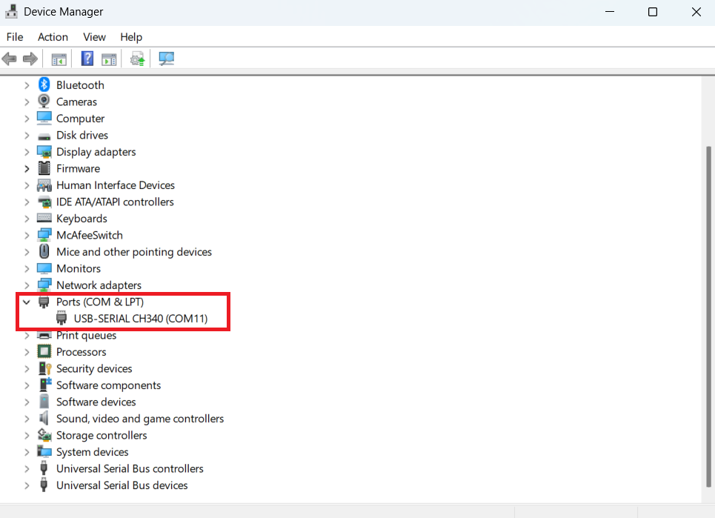
Figure 5: USB Device connect to the Desktop Computer or Laptop
- Use the “COM” port associated with the USB-SERIAL CH340. Select the serial port in the MATLAB desktop application and click the Connect button. It the “COM” port is not listed. Click on Refresh Ports to reload the available port to the drop-down menu.
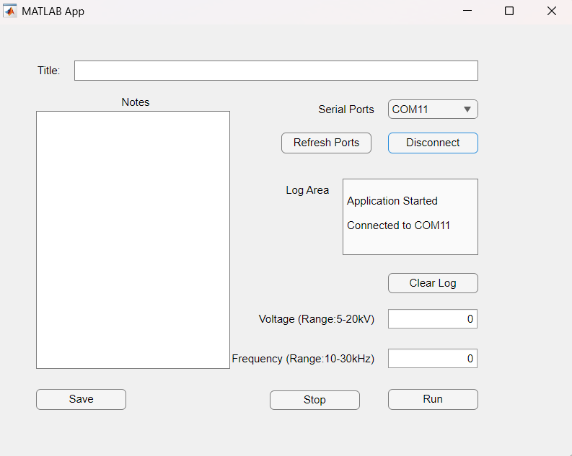
Figure 6: MATLAB Desktop Application Connected to the Serial Port
Configure the Power Supply Output using the Desktop Application
- Enter a kilovolt value for the Voltage field within the range of 5kV to 20kV. The value with a decimal will not work with the application. The voltage can be change with intervals of 1kV.
- Repeat Step 1 for the Frequency field with the range of 10kHz to 30kHz. The frequency values can be changed at intervals of 1kHz.
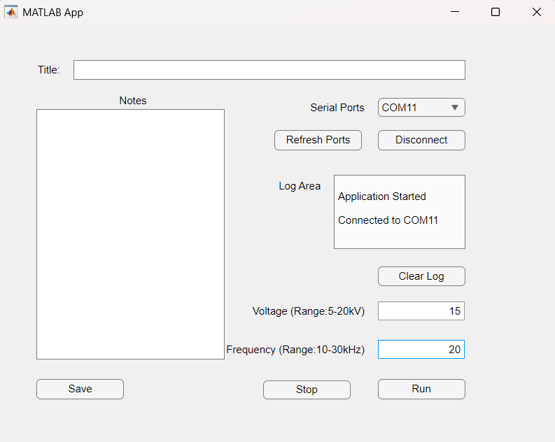
Figure 7: Desktop Application with Values in Voltage and Frequency Fields
- Turn on the input supply for the high voltage power supply and click the Run button to start the power supply.
Adjust the Power Supply Output Parameters with the Input Supply On
- The output parameters of the supply can be changed when the power supply is energized by clicking the Stop Button. The turns the power supply off.
- Edit the Voltage and Frequency field to the desired values and click Run to turn on the power supply.
- The Log Area shows messages based on the button pressed in the desktop application.
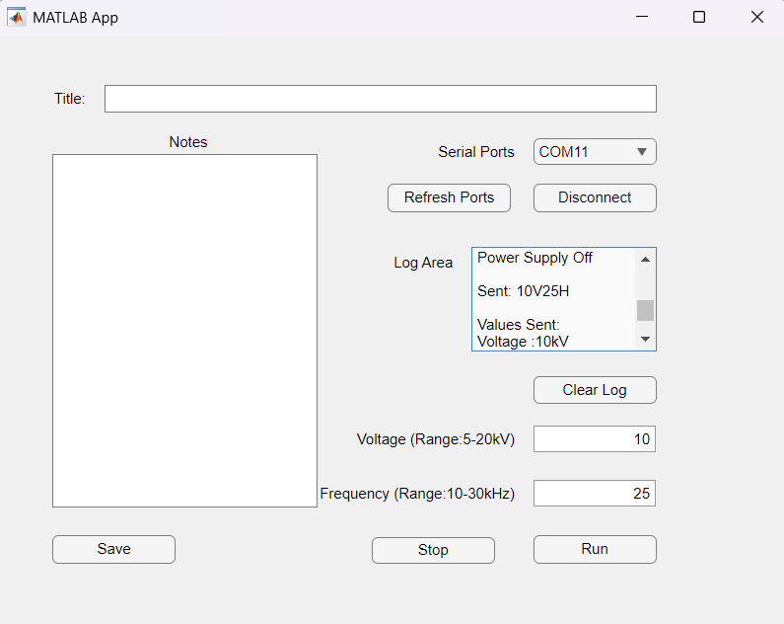
Figure 8: Power Supply Turned Off and On with Different Output Parameters
Record Notes with the Desktop Application
- The desktop application can take notes and save to a text file.
- Enter the name of the test or experiment on the Title area. This will be used for the name of the text file.
- Enter notes to the Notes area.
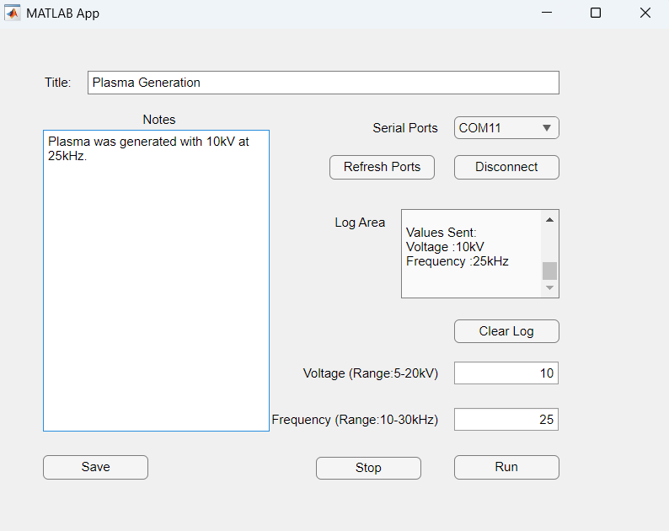
Figure 9: Title and Notes entered into the Application
- Click the Save button to create and save the notes as a text file with the name of the title. The text file is created in the folder that the desktop application “.mlapp” file is located.
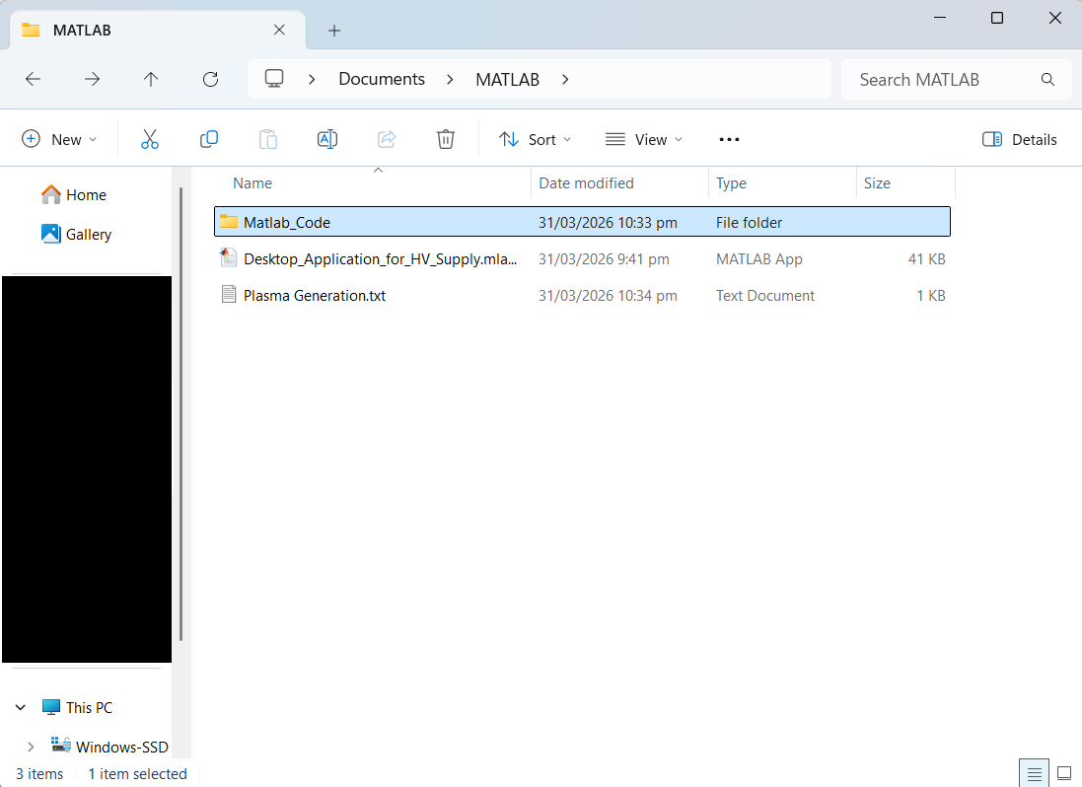
Figure 10: Location of the Created Text File
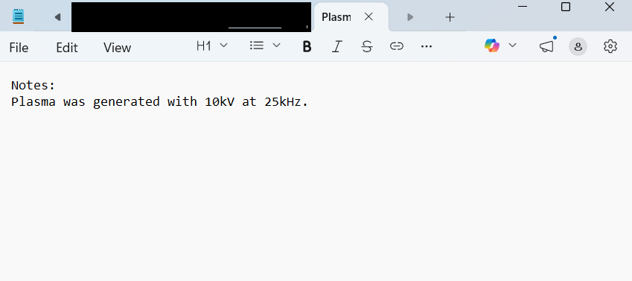
Figure 11: Contents of the Text File
Turn Off Power Supply and Disconnect Desktop Application
- Click the Stop button and turn off the input supply to the power supply.
- Click the Disconnect button on the desktop application to disconnect the USB port from MATLAB.
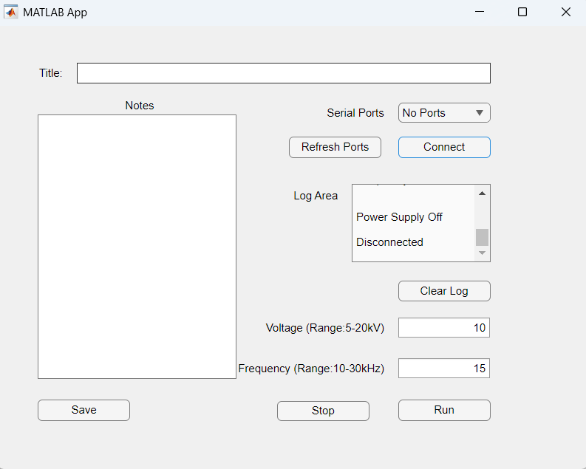
Figure 12: Power Supply Turned Off and Disconnected from the USB Port
- Close the “Desktop_Application_for_HV_Supply.mlapp” program and MATLAB.

